Aim - Amplitude Modulation : DSB-C with tone input
%NameVishal
%Enrollno.:03110402816
%Branch:ECE-2ndyear
fc=100000;%carrierfrequency
fs=1000000;%samplingfrequency
f=1000;%tonemodulation
m=0.5;%modulationindex
A=1/m; %amplitude of carrier from above relation for modulation.m
opt=-A;
t=0:1/fs:((2/f)-(1/fs));
x=cos(2*pi*f*t);
y=modulate(x,fc,fs,'amdsb-tc',opt);
subplot(2,2,1);
plot(x);
title('modulatingsignal-timedomain')
subplot(2,2,2);
plot(y);
title('DSB-Csignal-timedomain,m=0.5')
m=1.0;opt=-1/m;
y=modulate(x,fc,fs,'amdsb-tc',opt);
subplot(2,2,3);
plot(y);
title('DSB-Csignal-timedomain,m=1.0')
m=1.2;opt=-1/m;
y=modulate(x,fc,fs,'amdsb-tc',opt);
subplot(2,2,4);
plot(y);
title('DSB-C signal-time domain,m=1.2')
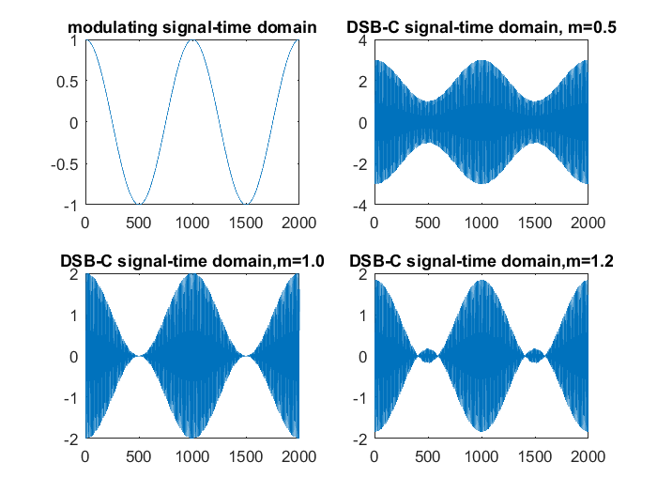
Published with MATLAB® R2016a

